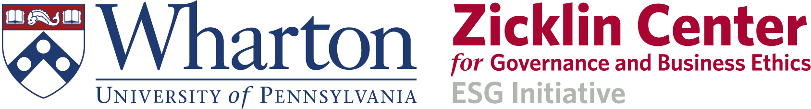
Business and Development Innovations

The Role of Young People in the Age of AIability
Global Social Impact: Actionable Cross Generational Knowledge Exchange

October 17, 2025
9:00-10:30 ET, Location: JMHH 240

This is a Wharton students and young professionals from our global partners, driven program. The event is part of our ongoing program Global Social Impact: Actionable Cross Generational Knowledge Exchange
with our global development partners, including the Tanoto Foundation.

Participants: This event will be held in a hybrid format, welcoming both in-person and virtual participants from around the world. It is open to Wharton and Penn students, recent alumni, and their peers, including students and young professionals, including researchers globally. Distinguished speakers and leading entrepreneurs will share their insights, with event details and follow-ups available through our website and social media platforms.

Organizers: Wharton/Penn students (mostly LGST 4010 and LGST 2300 students) in partnership with several Wharton/Penn student clubs.

Sponsors: Wharton Tanoto ASEAN Initiative, the Ziklin Center, and the Netter Center

Objective: The objective of this actionable cross generational knowledge exchange is to provide opportunities for the participants to expand their knowledge of sustainable development and AI implementation challenges and opportunities in countries in Asia, Africa, Latin America, and Eastern Europe (non-EU countries). This is also an opportunity for development professionals, corporate executives, researchers, and inventors to get insights into students and young professionals’ interest in and research on these issues, through AIability research papers.

Complementarity with the Wharton Impact, Value, and Sustainable Business Initiative. Focus is on sustainable development, AI, job creation, and what SDGs mean for frontier markets in the age of AIability. We will discuss governance in the context of ethics and value co-creation as a key element for successful implementation in emerging economies with weak institutions. How to shape the AIability ecosystem through human-centered approach and collective action. Building on the success of the Ideas for Action (I4A) program, which has engaged over 31,000 alumni globally, we will also focus on Ideas for Research (I4R) emphasizing collaboration among academia, practitioners, and young professionals to drive impactful solutions in sustainability and AI. The importance of capacity development and local partners, including think-thanks, and how this cross generational dialogue provides additional learning and knowledge exchange opportunities for students and young professionals, including young researchers – all of this in the context of the impact of AIability on the ecosystem, competitiveness, and value and job creation.

Website and social media coverage. We will have a website dedicated to this event. In addition to the limited number of in-person and on-line participants, the website and social media will provide opportunities for many others to get access to the abstracts/summaries of the presentations, the main takeaways, AIability Research papers, and future follow up activities.

The AIability framework, which integrates Artificial Intelligence with Sustainability was introduced at the OECD Global Partnership on AI Summit in December 2024

